Marketing Guide

Background:
- We have a problem with the reliable of the delivery, especially if are in 2 / 5 meters and we have as well lots of driver that we need to pay even for 2/5 meters
- The product is saving cost and will increase the reliable of the delivery
- With the robots we will safe the cost and will increase the reliable of the delivery

Market background:
Write a short description of your market and audience:
- Our target audience are users that need order food or items and want the delivery at home
- Our target market is the food delivery
- Competitor's target audience: "System delivery food and Urban delivery".Source: https://postmates.com/
Competitor's market share: 7%Source: craf.co Market Share and Competitor Report

Product Background and Positioning:

- With this product our value of market share will increase of 10%

- GPS Tracker this features permits to the customer to see where the robots it is.
- Anti Theft Mode with this features nobody can stoile the food inside the robots
- Pernolize delivery with this featues the customer can pesonalize the order

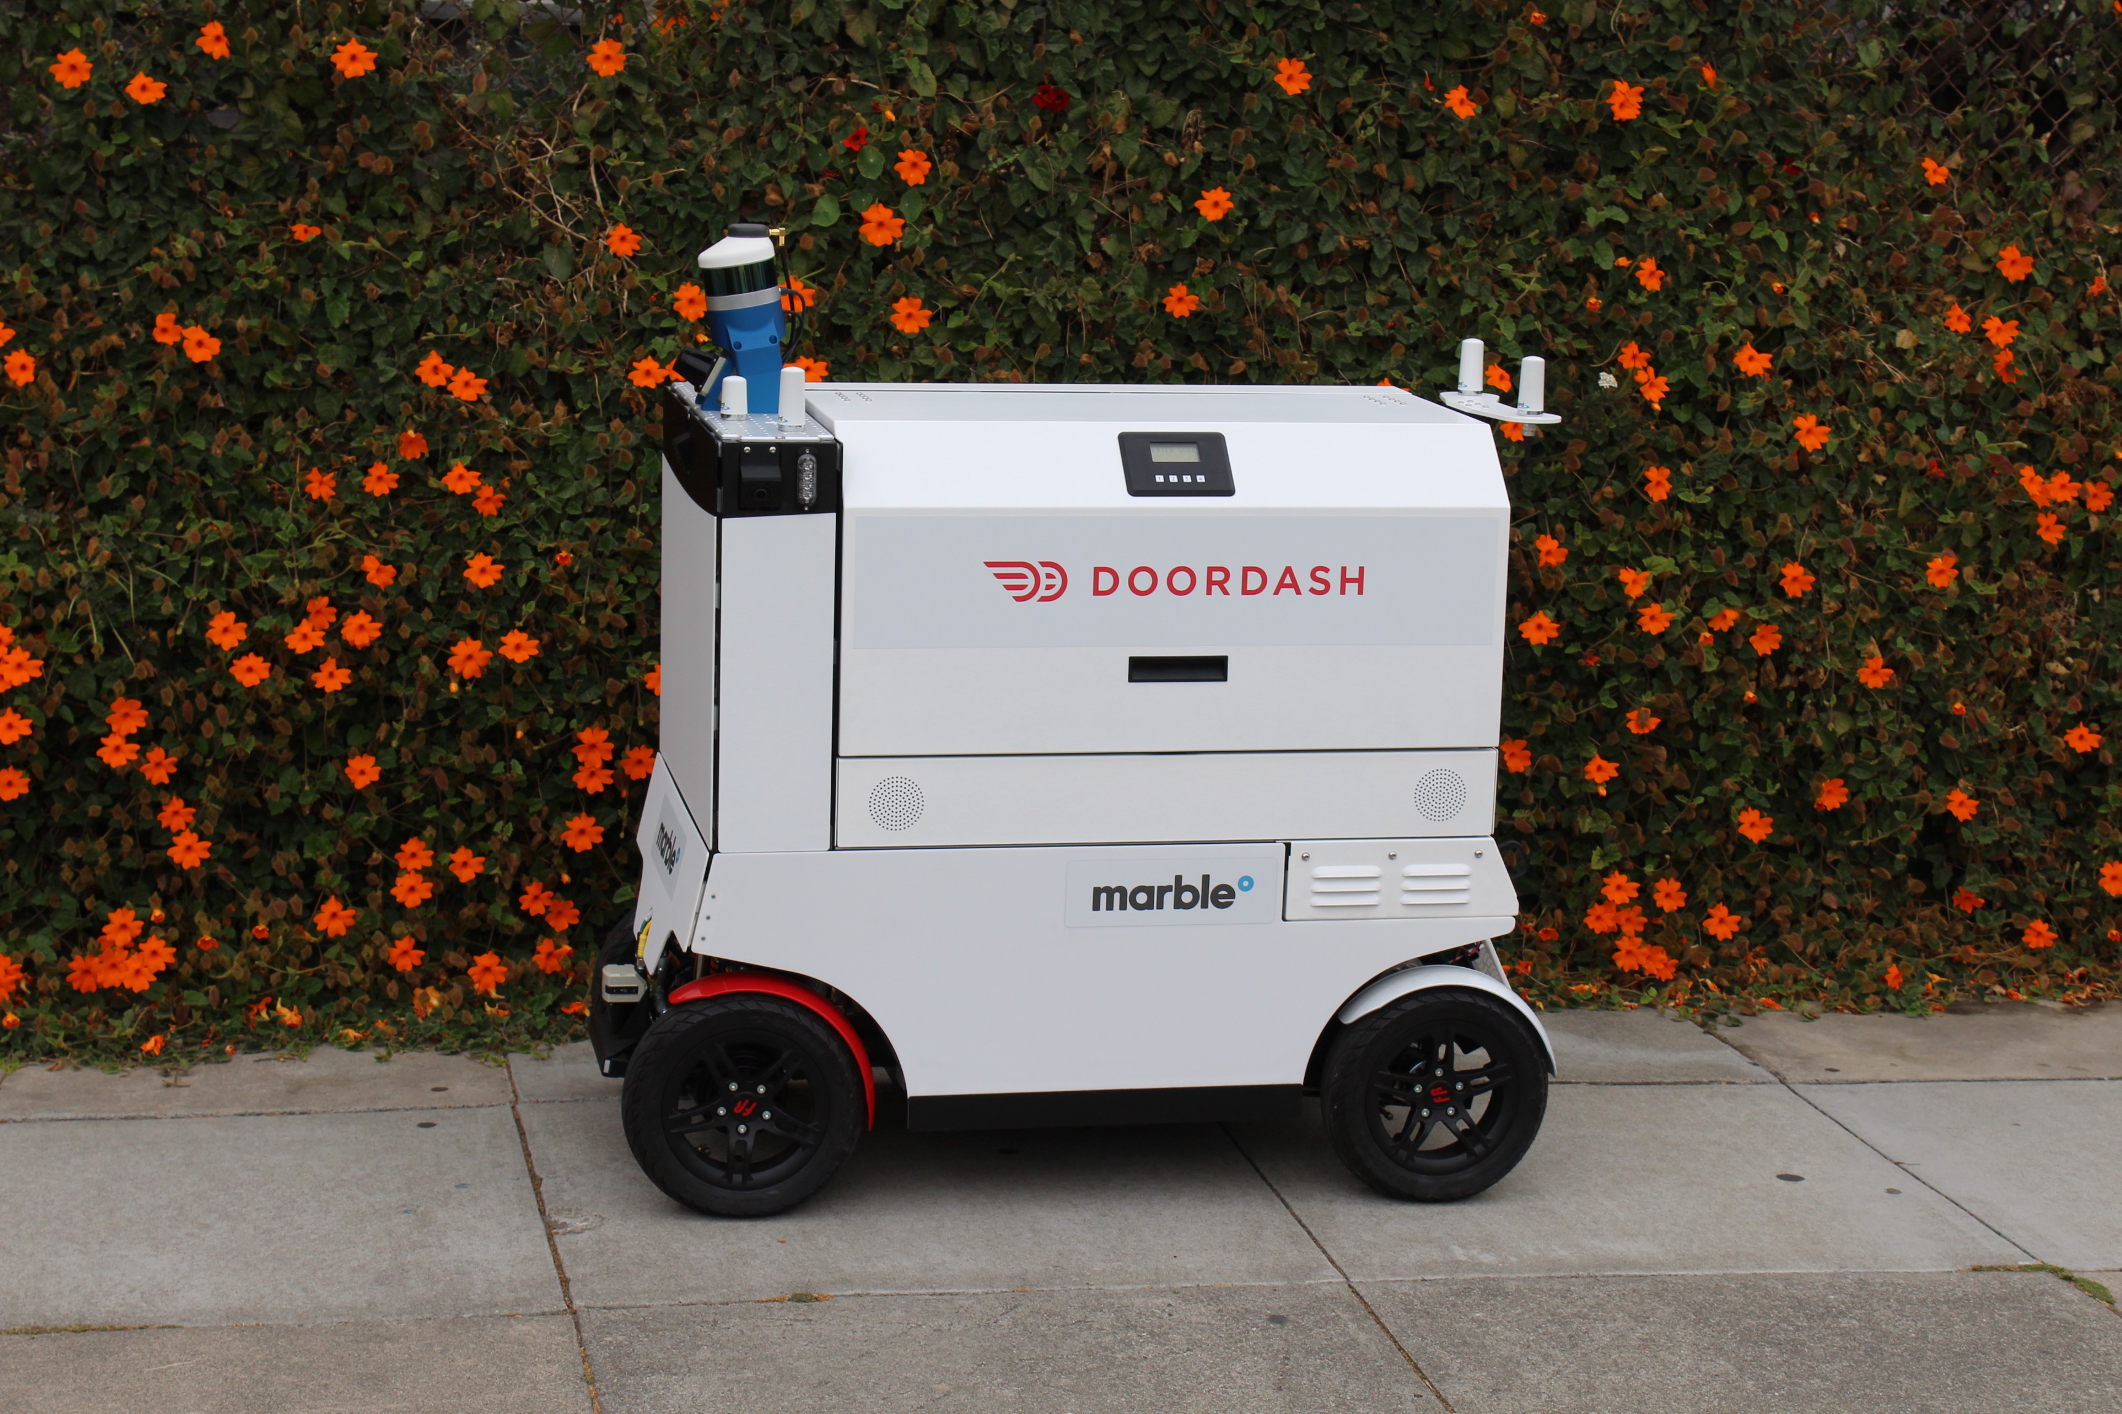
And here is our product

